9-2: Using ROLLUP and CUBE Operations and GROUPING SETS.

Vocabulary

Used to create subtotals that roll up from the most detailed level to a grand total, following a grouping list specified in the clause -CROUP BY

An extension to the GROUP BY clause like ROLLUP that produces cross-tabulation reports - CUBE

Used to specify multiple groupings of data – GROUPING SETS

Try It / Solve It

1. Within the Employees table, each manager_id is the manager of one or more employees who each have a job_id and earn a salary. For each manager, what is the total salary earned by all of the employees within each job_id? Write a query to display the Manager_id, job_id, and total salary. Include in the result the subtotal salary for each manager and a grand total of all salaries.

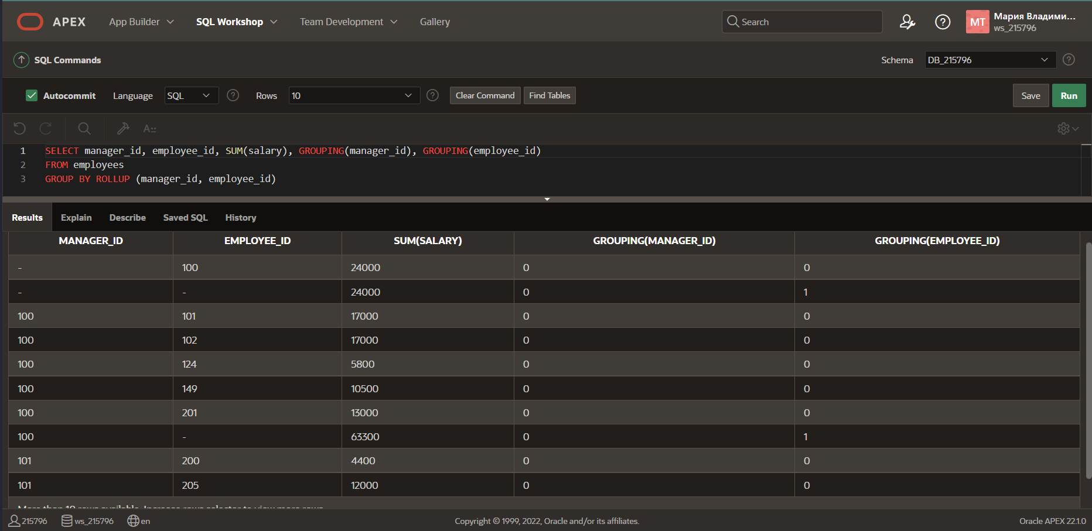

1. Amend the previous query to also include a subtotal salary for each job_id regardless of the manager_id.

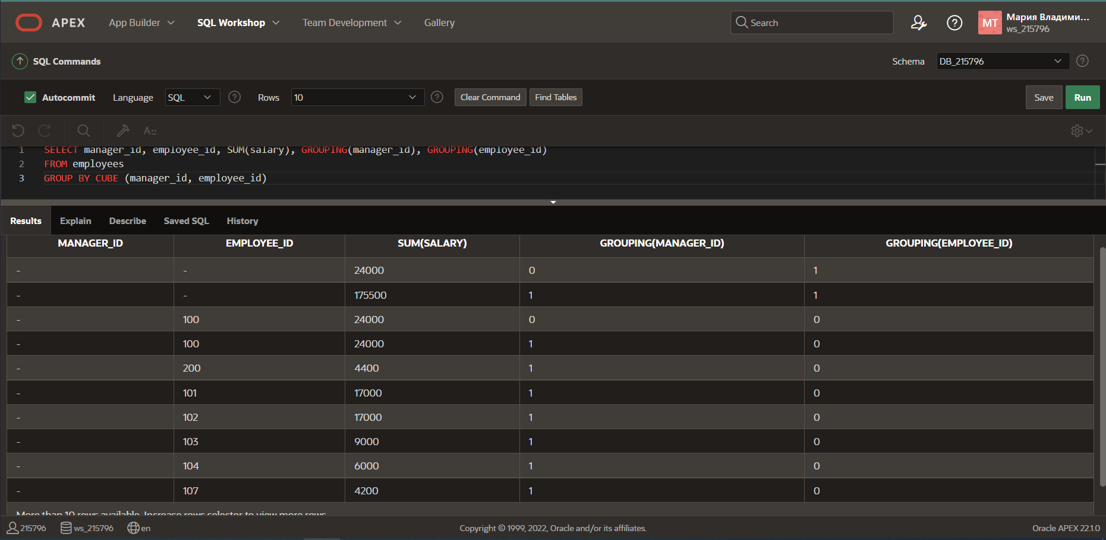

1. Using GROUPING SETS, write a query to show the following groupings:

• department_id, manager_id, job_id

• manager_id, job_id

• department_id, manager_id

